**OOP WS31 ATTENDANCE TO CLASS**

**DATE: 02th february 2022**

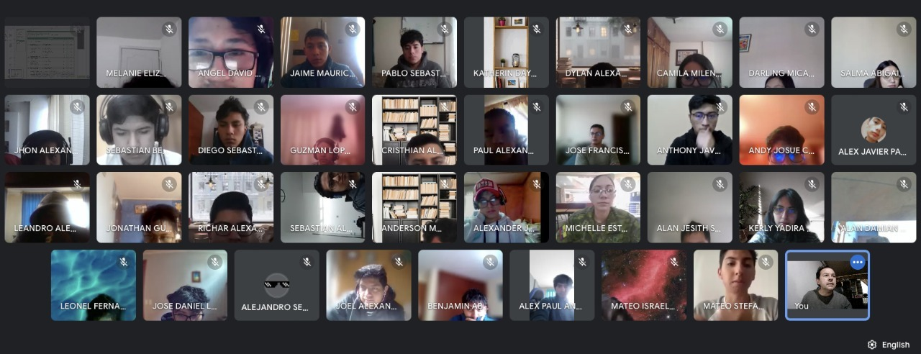

30 PALACIOS CANDO DIEGO SEBASTIAN                              10